User Manual Guide

**Contents**

**Chapter 1: Introduction ……………………………….03**

**Chapter 2: Overviews……………………………………04**

**Chapter 3: Controlling ………………………………….06**

**Chapter 1 : Introduction**

The project is designed to build an obstacle avoidance robotic vehicle using ultrasonic sensors for its movement. An Arduino Uno is used to achieve the desired operation. A robot is a machine that can perform task automatically or with guidance. Robotics is generally a combination of computational intelligence and physical machines (motors). Computational intelligence involves the programmed instructions. The project proposes robotic vehicle that has an intelligence built in it such that it guides itself whenever an obstacle comes ahead of it. This robotic vehicle is built, using an Arduino Uno. An ultrasonic sensor is used to detect any obstacle ahead of it and sends a command to the Arduino.

In today’s world ROBOTICS is a fast growing and interesting field. ROBOT has sufficient intelligence to cover the maximum area of provided space. Autonomous Intelligent Robots are robots that can perform desired tasks in unstructured environments without continuous human guidance. The obstacle detection is primary requirement of this autonomous robot. The robot gets the information from surrounding area through mounted sensors on the robot.

**Chapter 2 : Overviews**

Robotics is the branch of technology that deals with the design, construction, operation, and application of robots. A machine capable of carrying out a complex series of actions automatically, esp. one programmable by a computers is defined as a robot. The project is to develop a robot that will move according to the code assigned but find a free space, navigating from any obstacle on its way. This kind of obstacle is very useful in industries where automatic supervision is needed, for example, in places where it might be risky for humans to be. This robot can also be made by putting other sensors like light sensors or line sensors, ultrasonic sensors and ultrasound sensor depending on the need.

**Chapter 3: Controlling**

**To use this android controlling car you have to install a software first on your android. We provide you a software, which is BlueTooth Serial Controller.**

**After Installing , you have to open your Bluetooth connection .Then you should open your software. If you does not open your bluetooh and you run this software from your android then its show:**

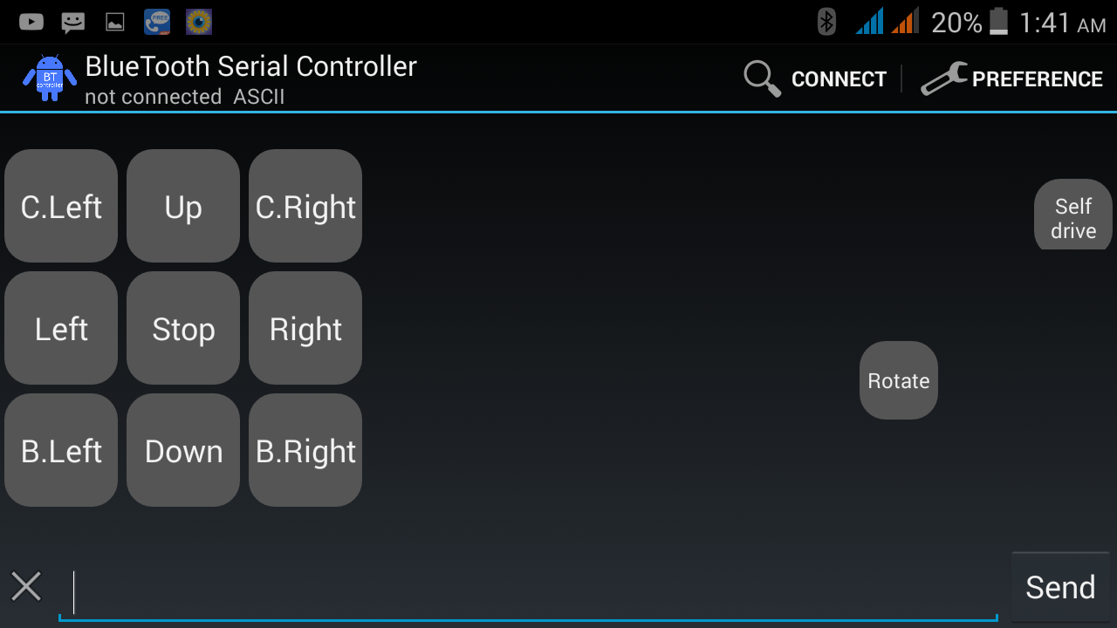

**You have press ‘Connect’ button for activation of your Bluetooth.**

**After activation you can see this type of picture:**

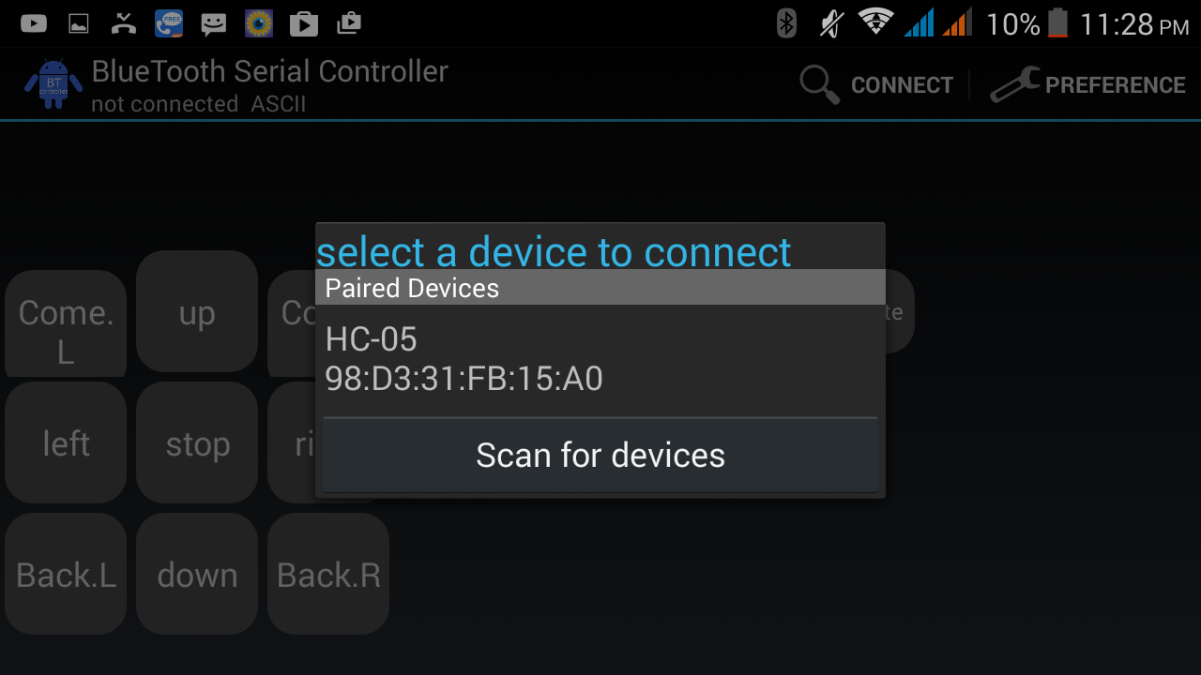

**Then you have to pair with HC-05 .**

**That means you are connected your android controlling car.HC-05 is the Bluetooth pair connection of your car.**

**After this work you can get your controlling system like this :**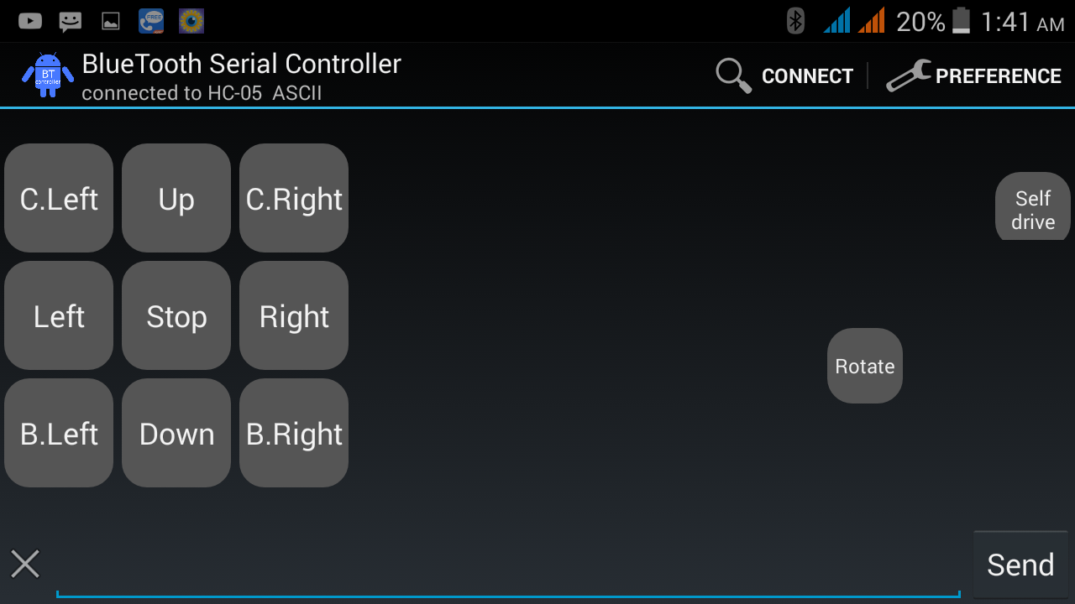

**1.UP: If you press ”up” button,your car will run for front.**



**2.STOP : If you press “stop” button,your car will Stop. (Does not move)**



**3.Left: If you press “left” button, your car will turn into left and run .**



**4.Right: If you press “right” button, your car will turn into right and run.**

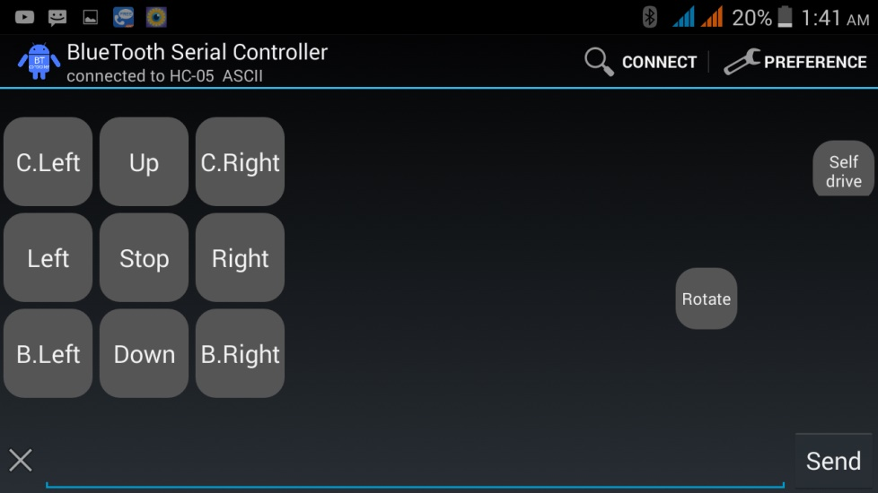

**5.Down: If you press Down button,your car will will run for back.**

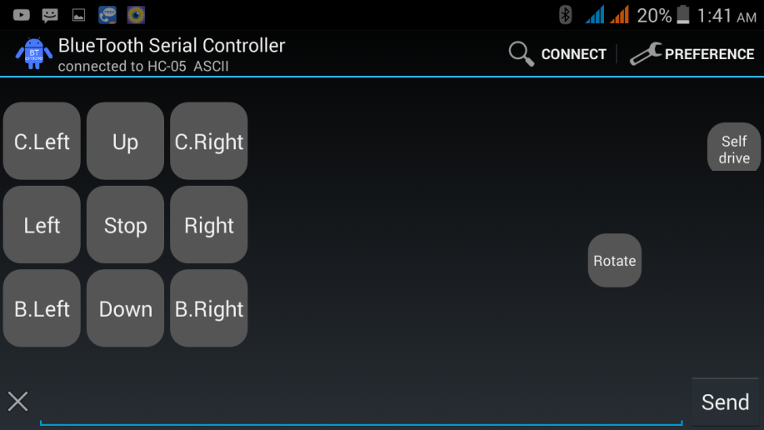

**6.Come.L: when the car come to you on that time if you want to move the car on your left then press “Come.L”.**

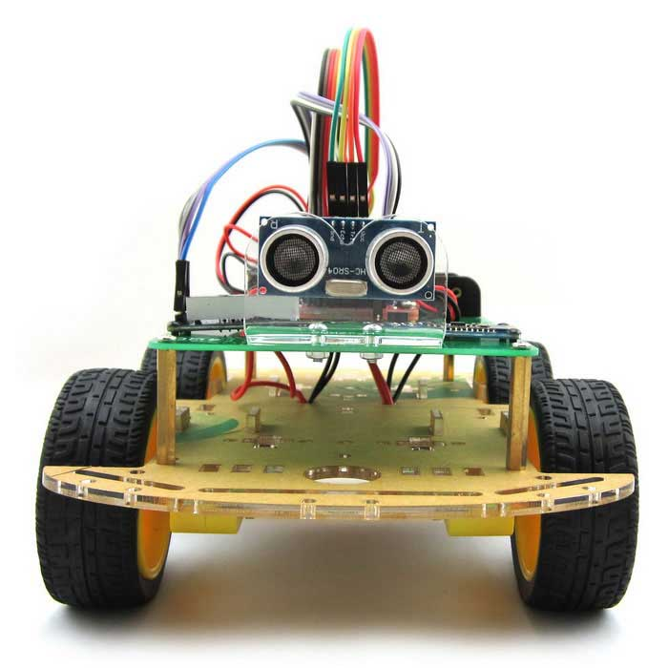

**7. Come.R: when the car come to you on that time if you want to move the car on your right then press “Come.R”.**



**8.Back.R:**

**If you want to turn your car back at a time right press “Back.R” button.**



**9.Back.L: If you want to turn your car back at a time right press “Back.L” button.**



**10.Rotate:**

**For rotating your car in 360 degree press “Rotate” .**



**11.Self-drive mode:**

**If you want to fix the car in self-drive mode then press “Self drive mode”.**

**In that case, you need to continue pressing on this button till you want.**

### ****THANK YOU****